Lab 4: Synthesis of Esters
Purpose:
To synthetically prepare and detect the odors of a number of esters.

Procedure:
- Prepare a hot water bath using a 400-mL beaker
- Number the three test tubes and put 1mL of a different alcohol in each of the three test tubes
- Add 1 mL of salicylic acid and a couple of drops of sulphuric acid to test tube 1
- Carefully add 1mL of acetic acid and a couple of drops of sulphuric acid to each of the test tubes 2 and 3
- Place all of the test tubes the water bath
- After about 5 minutes, pour the contents of each test tube into a separate evaporating dish and using the wafting method, identify the odour of each ester and record these observations on the data table.

Data Table:

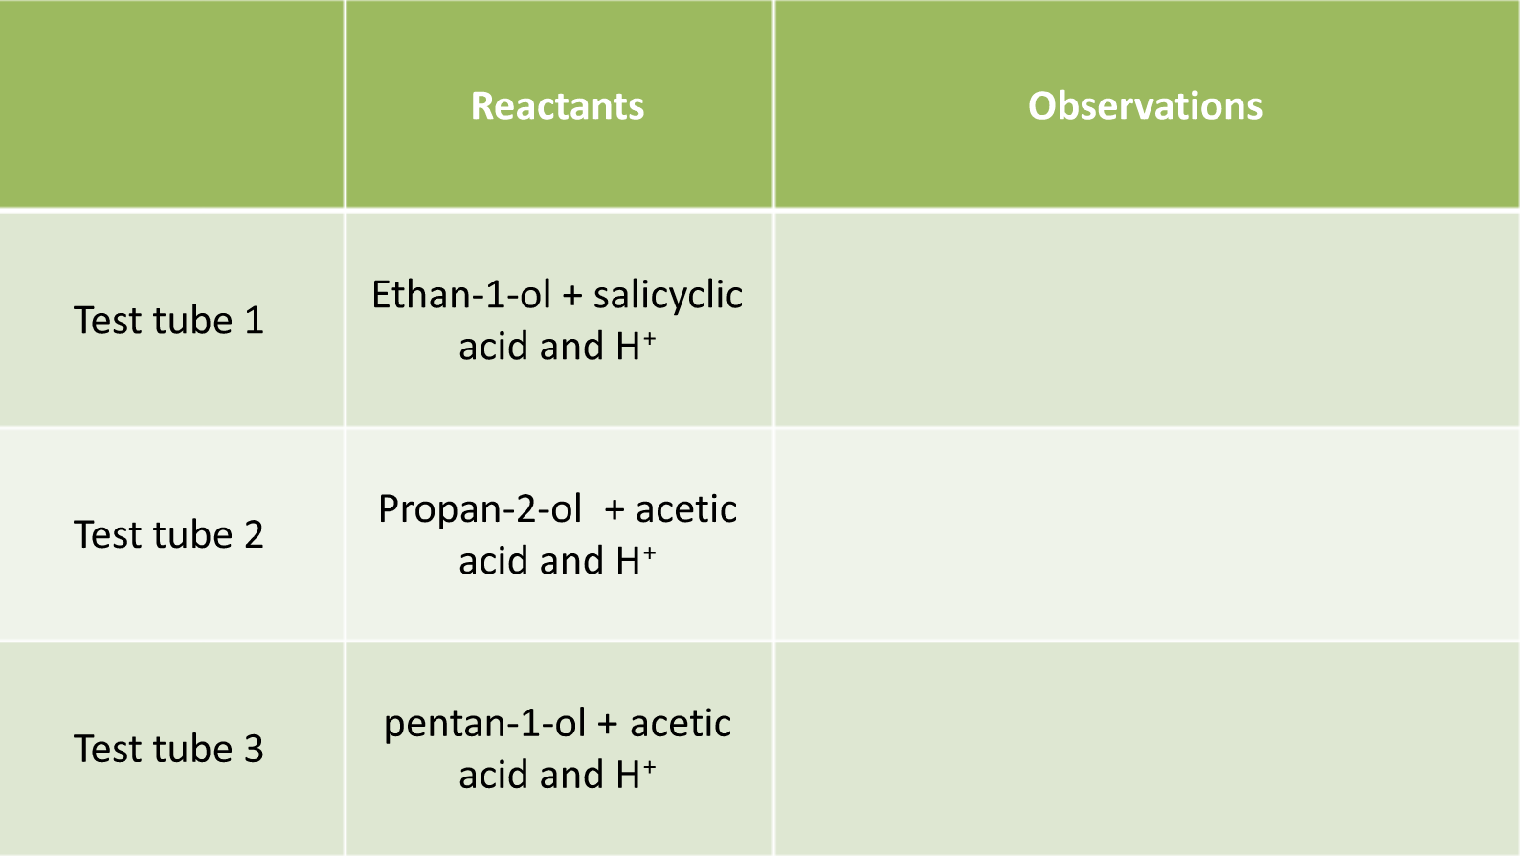

Link: https://www.youtube.com/watch?v=YI-os7Py8SM

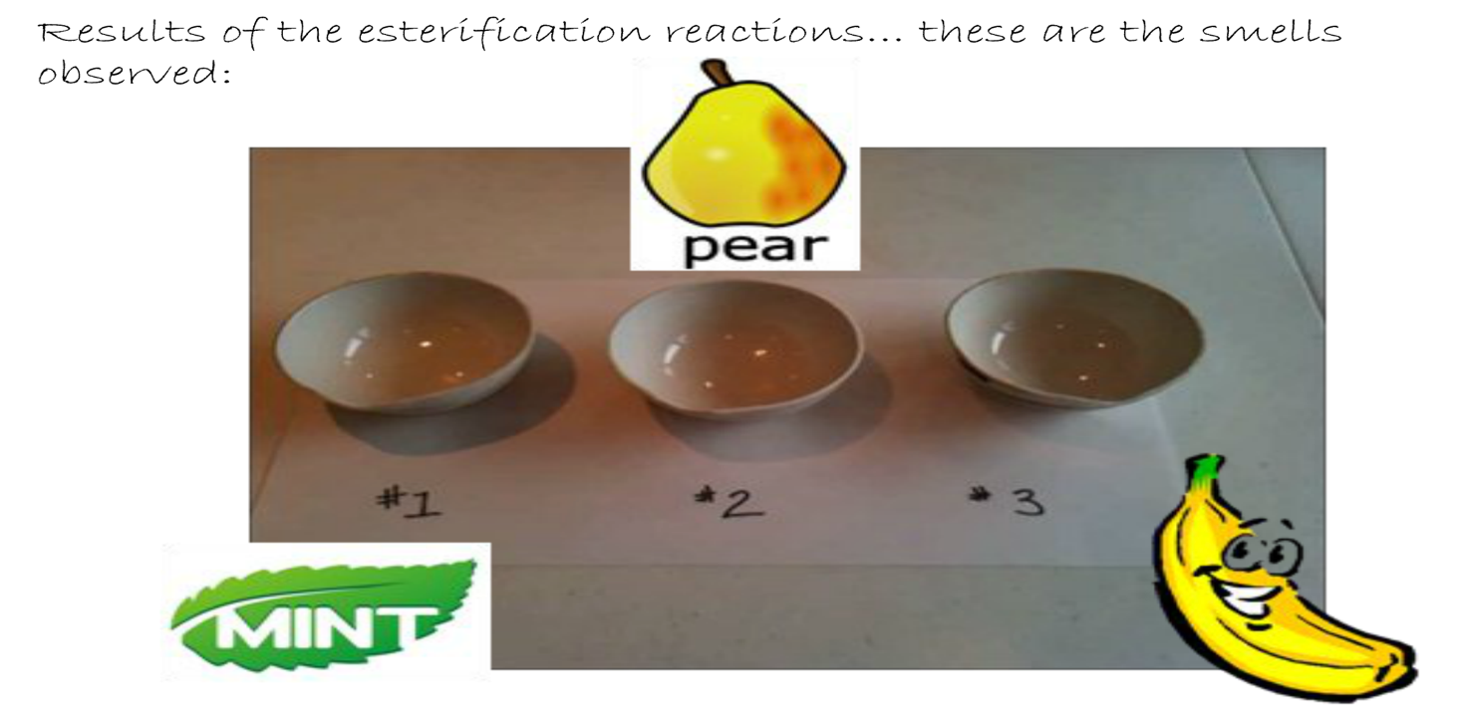

Questions:

- For each of the three reactions, draw structural diagram equations to represent each of the three esterification reactions. Be sure to the IUPAC name of each reactant and product.
- What was the function of the concentrated sulfuric acid in these reactions?
- Would the products of this investigation be soluble or insoluble in water? Explain your answer using intermolecular forces.
- Conclusion?

